**10. Transformation-Based POS Tagging**

**Aim:**  
To perform transformation-based POS tagging using a set of transformation rules.

**Algorithm:**

1. Define transformation rules.
2. Apply initial tagging.
3. Modify tags based on the rules.

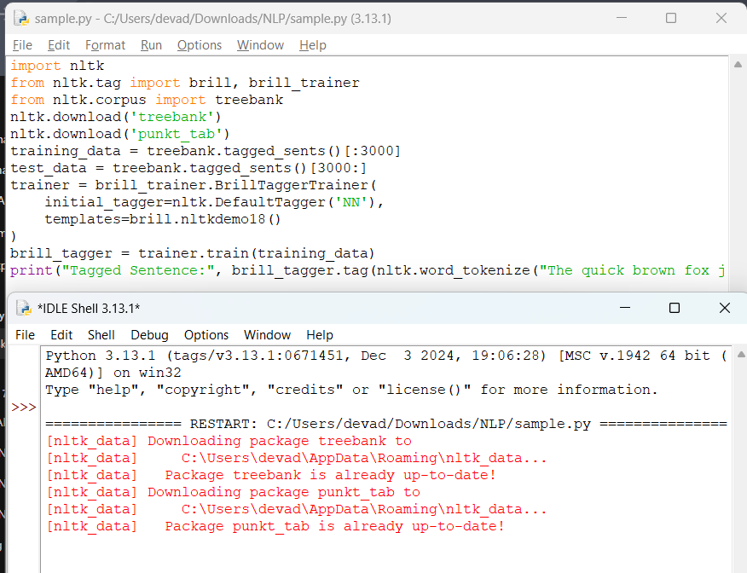

**Result:**  
Transformation-based POS tagging assigns tags based on rules.